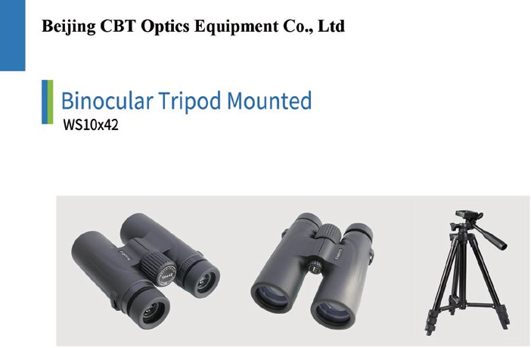

Optical Zoom (Magnification) | : 10x
Objective lens | : 42mm
Field of view | : 102m @ 1000m
Water/fog proof | : Yes
Optics coating | : Multi coated
Prism quality | : Barium crown glass
Weight | : 702g
Provided with | : Tripod
 | *Extended length:1000mm
 | *Folder length: 370mm
 | *Weight: 400g
Standard | : ISO
Accessories | : Lens clothe, Carrying case, Neck strap, Lens cap  operating manual in English/Chinese

