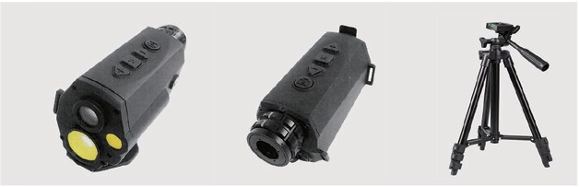

Key Features
It has tripod thread for using of tripod.

Type | : Multiple coated glass optics
Magnification | : 8x
Field of view | : 6.5°
Diopter adjustment | : ±5
Laser protection for observer | : Laser wavelength: 1535nm
Minimum measuring range | : 10meters
Maximum measuring range | : 5500meters
Accuracy | : ±1m
Laser classification | : Laser class 1
Display | : OLED display with reticle
Power source | : Rechargeable battery
Battery lifetime | : >3,000 measurements (per battery set, at 20oC  operating temperature)
Standards | : MIL-STD-810F
Water resistance | : IP67(30 minutes, 1m)
Operating temperature | : -30oC~+60oC
Storage temperature | : -40oC~+80oC
Provided with | : Tripod
 | *Extended length: 1670mm
 | *Folder length:620mm
 | *Weight: 1.87kg
Accessories | : Standard transport bag and operating manual in  English/Chinese & one charger.

